Clare DuVal and Jonathan Ayala

September 7, 2018

Lab 2

Lab Report

**Requirements Analysis**

Functional Requirements:

* The user inputs an amount to set the amount of columns.
* The system checks the amount of columns to keep it between 1 and 10.
* The user inputs an amount to set the amount of rows.
* The system checks the amount of rows to keep it between 1 and 10.
* The user enters numbers to fill each coordinate in their matrix.
* The system computes the transposed matrix to return it to the main.
* The system calculates the product of the sums of each row to return it to the main.
* The system calculates the average value in the matrix to return it to the main.
* The system calculates the sum of each column to return it to the main.
* The system calculates the sum of each row to the main.
* The system prints each respective matrix as a string for the user to view their results.

Non-Functional Requirements:

* The system must be written in Java for it to be run on Unix.
* The system must be able to compile on Clemson University’s computers for the user to be able to run it.

**Design**

Main Function

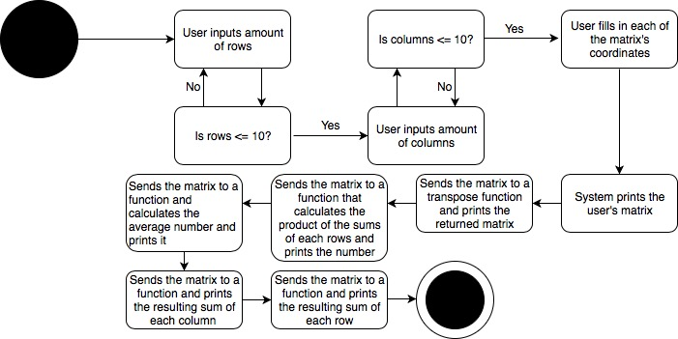

Converting a 2D Array to a String Function

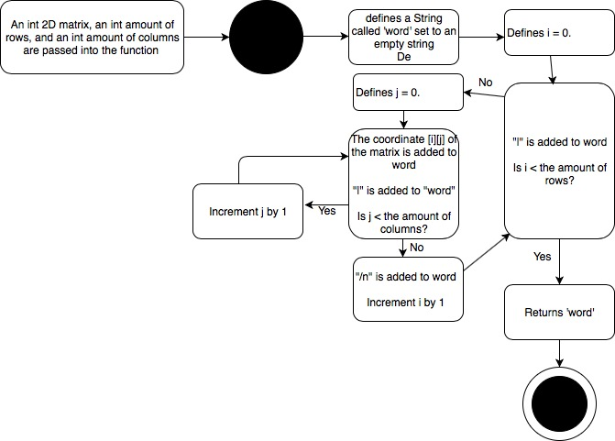

Transpose Function

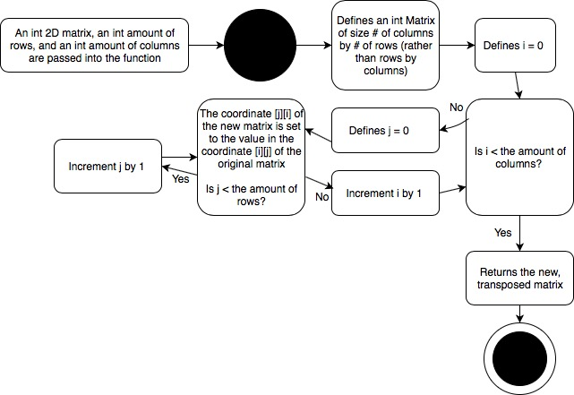

**Testing**

To test the success of the program, several tests were run. First, we tried square matrices of elements:

|5|6|

|1|8|

When we ran the program with these inputs, it returned:

Your matrix is:

|5|6|

|1|8|

The transposed matrix is:

|5|1|

|6|8|

The product sum is:

99

The average is:

5.0

The sums of each Column are:

|6|

|14|

The sums of each Row are:

|11|

|9|

We manually calculated each of the functions to make sure the product of sums, the average, and the row sums and column sums were calculated correctly. We also transposed the matrix manually to make sure it was correct.

We also ran the program with different amounts of rows and columns to make sure the transpose function could swap rows and columns of different sizes. We tried a rectangular matrix of:

|4|7|

|3|1|

|8|5|

When we ran the program with these inputs, it returned:

Your matrix is:

|4|7|

|3|1|

|8|5|

The transposed matrix is:

|4|3|8|

|7|1|5|

The product sum is:

572

The average is:

4.666666666666667

The sums of each Column are:

|15|

|13|

The sums of each Row are:

|11|

|4|

|13|

When we tried inputting rows or columns of more than 10 elements, the program produced an error.

**Deployment**

To compile the code on unix, you must first make an exact folder duplicate of the original program file (i.e. Make a copy of the MatrixFun folder and put it on unix.). Then, go to the directory where the MatrixApp.java is located. Once there, to compile, you type ‘javac MatrixApp.java’, which then creates a class of the MatrixApp.java. In order to run, you must go outside the package folder your MatrixApp.java is in (i.e. if your package is cpsc2150.lab2, go to the folder before cpsc2150). Once there, to run the program, you type ‘java cpsc2150.lab2.MatrixApp’. If your program has no errors, you should have compiled and ran your program successfully.